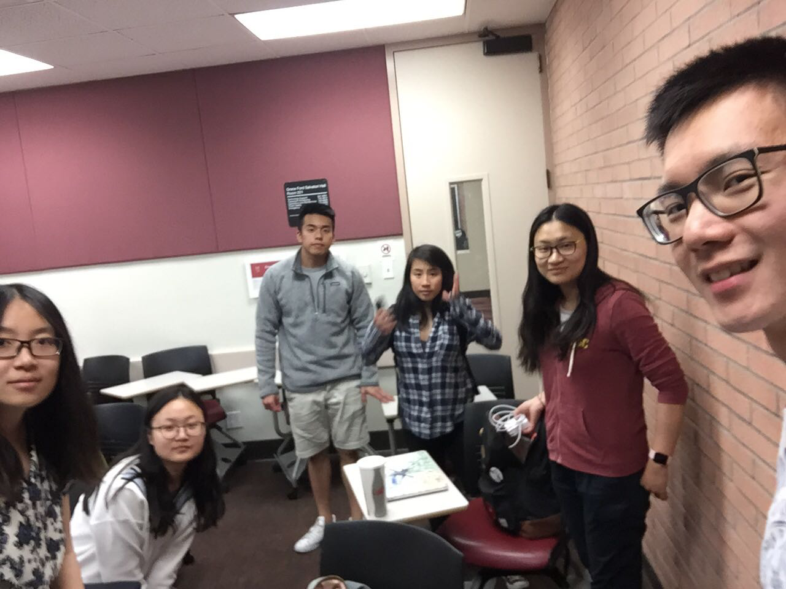

Allocated meeting time: April 10th, 8:00pm-9:00pm

Actual meeting time: April 10th, 8:00pm-9:00pm

Product owner: Professor Halfond, TAs, CPs

Scrum master: Gong Chen

Team members: Lingyi Li, Joann Lin, Peixuan Liu, Ryan To, Tuling Zhao

Scrum summary:

We were working on making the test cases as well as the implementation of saving collage functionality.

1. What have you accomplished since the last meeting?
2. Are there any obstacles in the way of meeting your goal?
3. What will you accomplish before the next meeting?

Gong Chen:

1. Test for export. Fixing the location of main collage with help of tuling.
2. None
3. Getting advice from instructors on the pair programming section on the document

Lingyi Li:

1. I added contents in sprint backlog and scrum meeting information in the sprint process report.
2. None.
3. I will continue writing the deliverable

Joann Lin:

1. I continued to refine and test save collage and view saved collage functionality
2. No obstacles
3. I will push it to GitHub and make sure there are no merge conflicts

Peixuan Liu:

1. Help Gong to write test for export.
2. None
3. Getting advice from instructors on how to write white-box tests

Ryan To:

1. I continued to work on the loader and cleaned up the css on master branch
2. No obstacles
3. Working on implementing https feature

Tuling Zhao:

1. I fixed collage displaying error
2. None
3. Will write black box test for save collage and search on https test